OO Programming Fundamentals

Practical Week 5 – 13th October 2014

Create a Practical Week 5 folder in your Java folder on your G drive

G:\Java\Practical Week 5

- Save all the following exercises into the Practical 5 folder

Exercise 1
Write a program which takes as input any three integer values, and determines which is the largest number.

Create project in Practical Week 5 folder as: ex5a
Sample Output
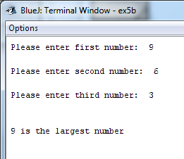

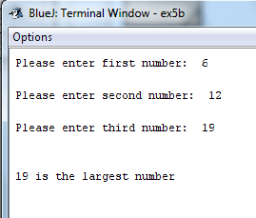

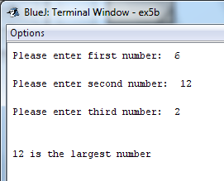

Exercise 2:
Write a program to read a month number (i.e. 1 to 12) and print one of valid or not valid.

Create project in Practical Week 5 folder as: ex5b
Sample Output

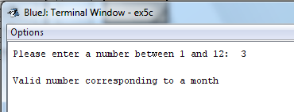

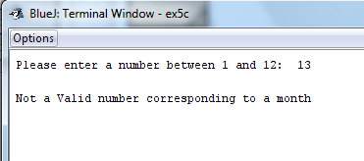
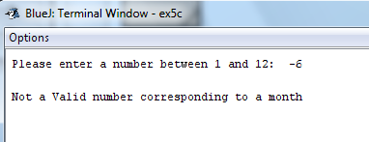

Exercise 3:
A coach is organising a sporting event and wishes to separate competitors into three different categories according to age. The three categories are as follows:
- Under 14 Category A
- 14 but under 16 Category B
- 16 or over Category C
Write a program that requests a user to enter the age of a competitor and outputs the appropriate category.

Create project in Practical Week 5 folder as: ex5c

Sample Output
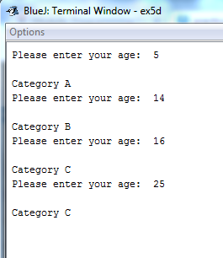

Exercise 4:

Write a program to read a student’s percentage mark, check that it is valid and, if so, print one of distinction, merit, pass, or fail.
Note: A valid mark is one in the range 0 .. 100 and the grades are broken down as follows: 100 ≥ distinction ≥ 80, 79 ≥ merit ≥ 65, 64 ≥ pass ≥ 50, fail ≤ 49

Create project in Practical Week 5 folder as: ex5d
Sample Output
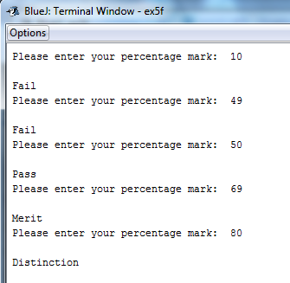

Exercise 5:

Enter the following program from lecture notes: 7.1 Selection Tutorial Exercises

Write a program that presents a menu to the user.

***Marital Status***

Single (S, s)
Married (M, m)
Divorced (D,d)
In a Relationship (R,r)

Ask the user to enter in their name:
Ask the user to enter in their marital status s, m, d, r:
Depending on their response, reply to them with an appropriate message "You are Single", "You are Married", etc.

Write with a Nested If Statement and save as ex5e1
Rewrite with a Switch Statement and save as ex5e2
Sample Output
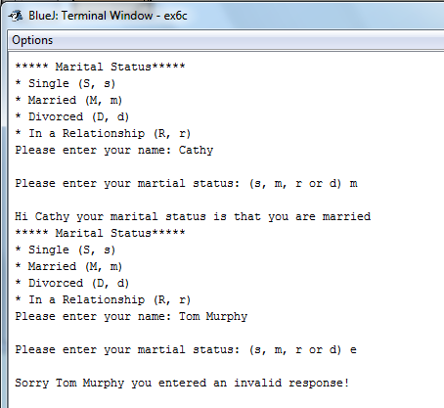

Exercise 6:
Write a program that prints the following menu to the user:

COMPUTERS ‘R’ Us

--------------------------

Which product would you like to buy:
1. Computer
2. Laptop
3. Tablet
4. Exit
Enter your choice (1,2 or 3):

Use a Switch Statement to carry out the following:

- If the user entered a 1, print out that they chose a computer
- If the user entered a 2, print out that they chose a laptop
- If the user entered a 3, print out that they chose a tablet
- If the user enters 4 the program should end.
- If the user entered an invalid option e.g. 5, print out that they chose an invalid option, e.g.:

Create project in Practical Week 5 folder as: ex5f

Sample Output
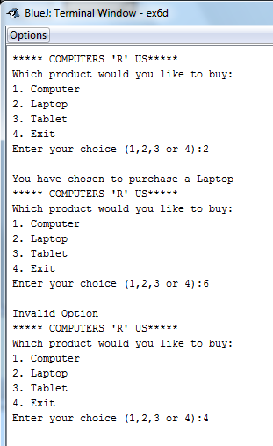

Completing this weeks’ Practical:
- When you submit work, you will send it in zip file format.
- To create a zip file of your practical work:
  - In Windows Explorer, right click on the Practical Week 5 folder that contains your work.
  - When the context menu appears, choose the Send to option, followed by the Compressed (zipped) folder.
  - This will create a new file called Practical Week 5.zip in your current folder
- Note: If you are using your own laptop, you can choose to install very good (and free) compression software called 7zip. Just search for it in Google and download it.

*** It is this zipped file that you will upload into Moodle.***

